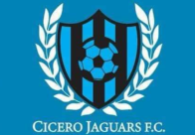 Cicero Jaguars F.C. LLC
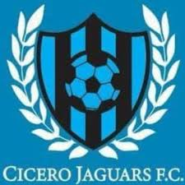
Sponsorship Levels
Fan: $100
- Logo, name, and web address of your company on our website.
- Optional: Distribute promotional items.
Player: $250
- Logo, name, and web address of your company on our website.
- Logo on all flyers and printed promotional material.
- Company name mentioned on the sponsor list at the end of every “Cicero Jaguars” YouTube video.
Team Captain: $500
- Logo, name, and web address of your company on our website.
- Logo on all flyers and printed promotional material.
- Company name mentioned on the sponsor list at the end of every “Cicero Jaguars” YouTube video.
- Logo on our social networking sites Facebook (Cicero Jaguars F.C.), Instagram (cicerojaguars), and Twitter (@CiceroJaguars): Post at least once a month on each.
Coach: $1,000
- Logo, name, and web address of your company on our website.
- Logo on all flyers and printed promotional material.
- Company name mentioned on the sponsor list at the end of every “Cicero Jaguars” YouTube video.
- Your company logo displayed on at least one post per month on each of our social networking sites Facebook (Cicero Jaguars F.C.), Instagram (cicerojaguars), and Twitter (@CiceroJaguars).
- 2” logo size on jerseys.
Manager: $2,500
- Logo, name, and web address of your company on our website.
- Logo on all flyers and printed promotional material.
- Company name mentioned on the sponsor list at the end of every “Cicero Jaguars” YouTube video.
- Your company logo displayed on at least one post per month on each of our social nerworking site Facebook (Cicero Jaguars F.C.), Instagram (cicerojaguars), and Twitter (@CiceroJaguars).
- 3” logo size on jerseys.
- Banner with picture and company name on home outdoor field.
MVP: $5,000
- Logo, name, and web address of your company on our website.
- Logo on all flyers and printed promotional material.

- Company name mentioned on the sponsor list at the end of every “Cicero Jaguars” YouTube video.
- Logo on our social networking sites Facebook (Cicero Jaguars F.C.), Instagram (cicerojaguars), and Twitter (@CiceroJaguars).
- 4” logo size on jerseys.
- Banner with picture and company name on home outdoor field.
- Outdoor banner stand at home games and special events.
- Company boot at special events for advertisement.

